Date | 03-10-2026
Team ID | SWTID-2026-8713
Project Name | Implement Client Script & UI Policy (Incident)
Maximum Marks | 5 Marks

Project Planning Phase
Product Backlog, Sprint Schedule, and Estimation
The following table outlines the product backlog and sprint schedule for implementing Client Scripts and UI Policies on the ServiceNow Incident form so that fields become mandatory, read-only or visible when defined conditions are met.
Sprint | Functional Req  (Epic) | USN | User Story / Task | Point  s | Priority | Team  Members
Sprint-1 | UI Policy –  Mandatory Fields | USN-1 | As a developer, I can create a UI policy that  makes Close code and Close notes  mandatory when State is Resolved or  Closed. | 3 | High | Thabeshwin
Sprint-1 | UI Policy –  Mandatory Fields | USN-2 | As a developer, I can make Short  description mandatory for every new  incident. | 2 | High | Thabeshwin
Sprint-1 | UI Policy –  Visibility and  Read-only | USN-3 | As a developer, I can show or hide fields  (for example, On hold reason) based on  State and Category. | 5 | High | Supriya
Sprint-2 | UI Policy –  Visibility and  Read-only | USN-4 | As a developer, I can make fields read-only  for closed incidents. | 1 | Medium | Thabeshwin
Sprint-2 | Client Script –  onLoad | USN-5 | As a developer, I can write an onLoad  Client Script that sets the initial form state  and shows guidance. | 2 | High | Supriya
Sprint-2 | Client Script –  onChange | USN-6 | As a developer, I can write an onChange  Client Script on Category, State, Impact or  Urgency that updates other fields. | 3 | High | Supriya
Sprint-2 | Client Script –  onSubmit | USN-7 | As a developer, I can write an onSubmit  Client Script that validates the data before  save. | 3 | High | Supriya
Sprint-2 | Form Guidance | USN-9 | As a service desk agent, I see only the  fields that matter for the current State and  Category. | 2 | High | Supriya
Sprint-2 | Form Guidance | USN-  10 | As an agent, I get a clear message when I  enter incorrect or inconsistent data. | 1 | High | Supriya
Sprint-3 | Testing and  Verification | USN-8 | As a developer, I can test every rule by  changing fields on the form and checking  the browser console. | 5 | Medium | Sakthivel S
Sprint-3 | Rule Maintenance | USN-  11 | As an administrator, I can activate,  deactivate and update the Client Scripts  and UI Policies. | 3 | Medium | Vishal
Team members: Vishal (requirements & configuration), Thabeshwin (UI Policy – mandatory and read-only), Supriya (UI Policy – visibility and Client Scripts), Sakthivel S (testing and documentation).

Project Tracker, Velocity & Burndown Chart
Tracking sprint progression, calculating team velocity, and visual reporting methodology.
Sprint | Total Story  Points | Duration | Sprint Start  Date | Sprint End Date  (Planned) | Story Points  Completed | Sprint Release  Date (Actual)
Sprint-1 | 10 | 10 Days | 05 Oct 2026 | 16 Oct 2026 | -- | --
Sprint-2 | 12 | 10 Days | 19 Oct 2026 | 30 Oct 2026 | -- | --
Sprint-3 | 8 | 10 Days | 02 Nov 2026 | 13 Nov 2026 | -- | --

Velocity Calculation
Each sprint is planned for 10 working days. The planned workload is 10, 12 and 8 story points for Sprints 1, 2 and 3 (30 points in 30 days).
Average Velocity (AV) = Total Story Points / Total Sprint Days = 30 points / 30 days = 1.0 Story Point per Day
Planned velocity: 30 points / 3 sprints = 10 story points per sprint.
The "Story Points Completed" and "Sprint Release Date (Actual)" columns are filled in as each sprint is closed.

Burndown Chart
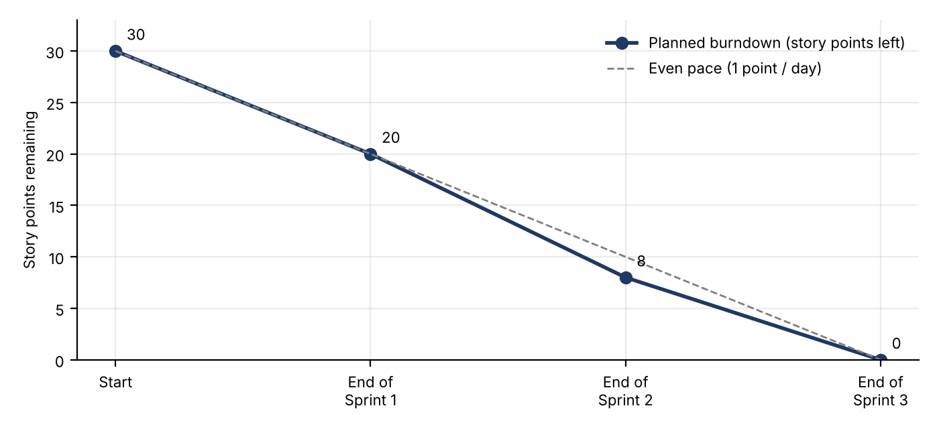
Planned burndown for the three sprints (actual progress is added as stories move to Done)
A burndown chart is a graphical representation of work left to do versus time. In this project the Y-axis shows the outstanding story points (starting at 30) and the X-axis shows the sprint timeline. As stories such as the Mandatory Fields UI Policy (USN-1) or the onSubmit Client Script (USN-7) are moved to "Done", the line drops, giving measurable progress and showing whether the Incident form rules will be delivered on schedule.

